🎨 6️⃣ HTML COLORS
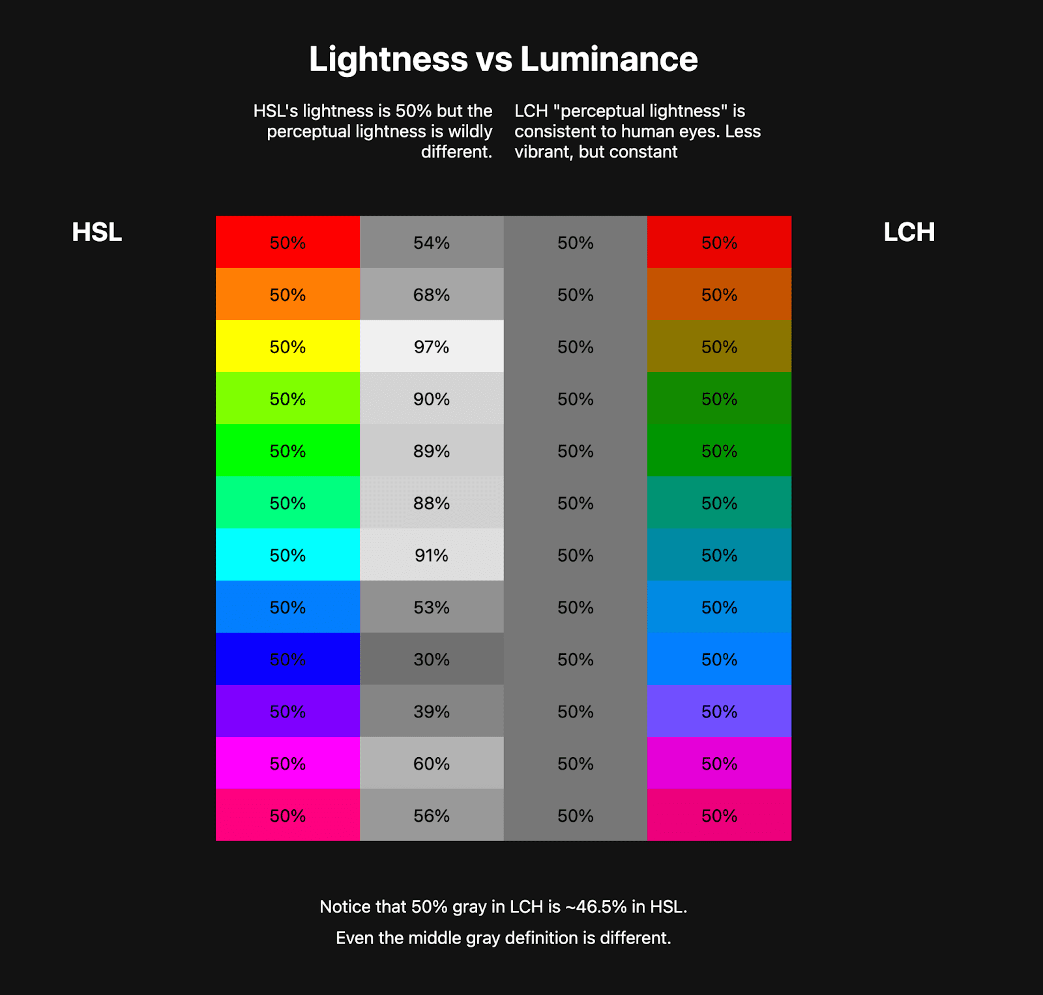
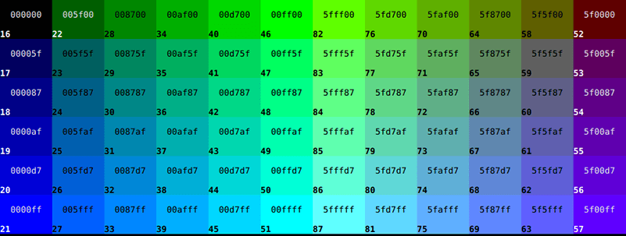
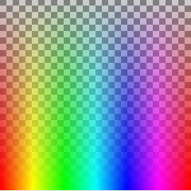

HTML colors control how text and elements look visually.
🔹 Color Types
1️⃣ Color Names
<p style="color:red;">Red Text</p>
✔ Easy to read
❌ Limited range
2️⃣ HEX Colors (MOST USED 🔥)
<p style="color:#ff5733;">HEX Color</p>
• Format: #RRGGBB
• Values from 00 to FF
• Used in real projects
3️⃣ RGB / RGBA
color: rgb(255, 0, 0);
color: rgba(255, 0, 0, 0.5);
✔ RGBA supports transparency
4️⃣ HSL / HSLA
color: hsl(0, 100%, 50%);
✔ Designers prefer HSL (easy tuning)
📌 Interview Tip:
HEX = most common | RGBA = transparency | HSL = designer-friendly

🔗 7️⃣ HTML LINKS
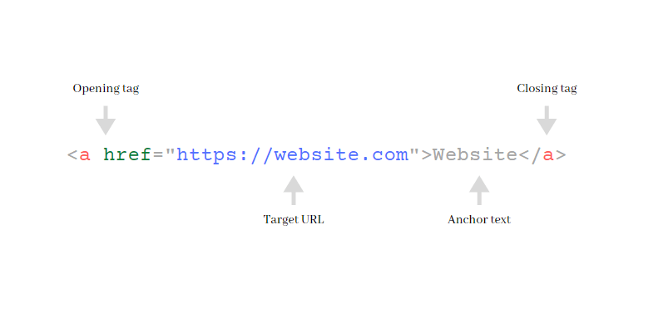

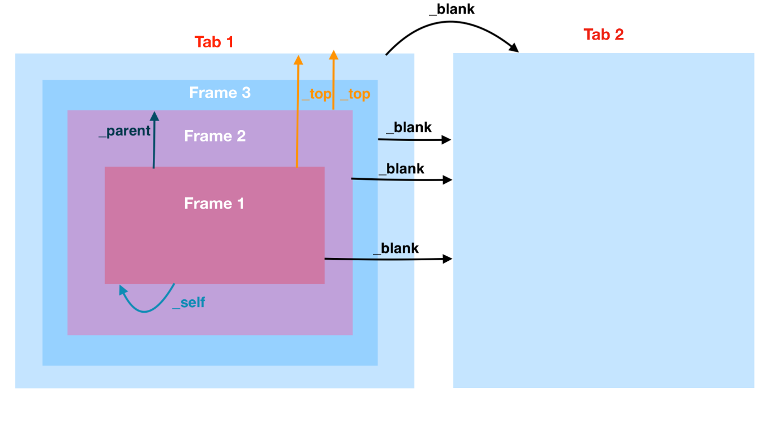

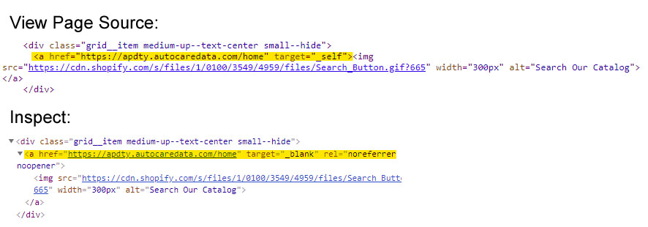
Links are the navigation system of the web 🌐
🔹 Anchor Tag
<a href="https://google.com">Google</a>
🔹 URL Types
Absolute
<a href="https://example.com/page.html">
Relative
<a href="about.html">
📌 Relative URLs preferred inside projects.
🔹 Target Attribute
<a href="page.html" target="_blank">Open</a>
Value | Meaning
_self | Same tab
_blank | New tab
🔹 Email, Phone & Bookmark
<a href="mailto:test@gmail.com">Email</a>
<a href="tel:9876543210">Call</a>
<a href="#section1">Bookmark</a>

🖼️ 8️⃣ HTML IMAGES & MEDIA

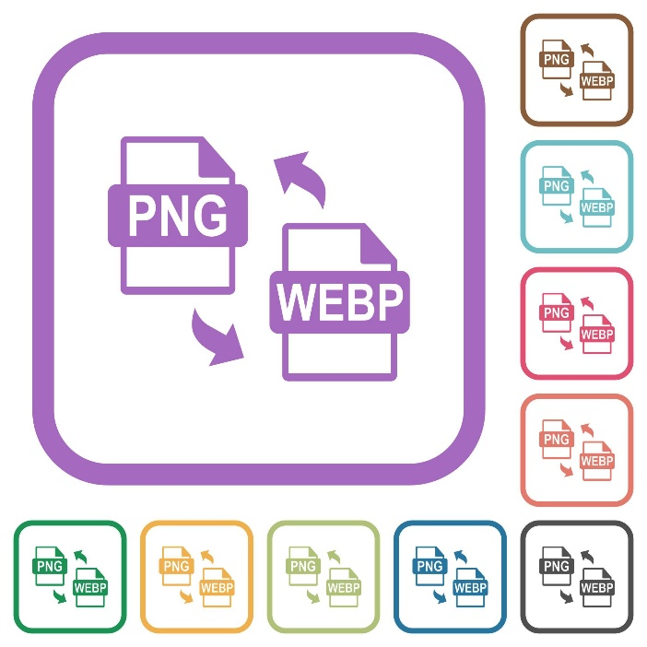
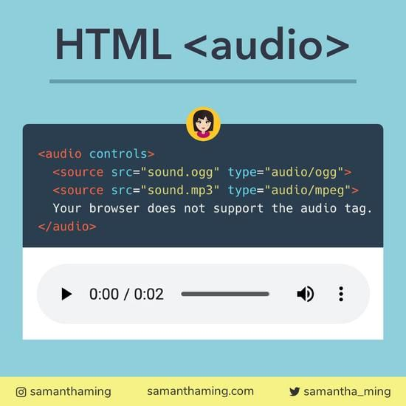
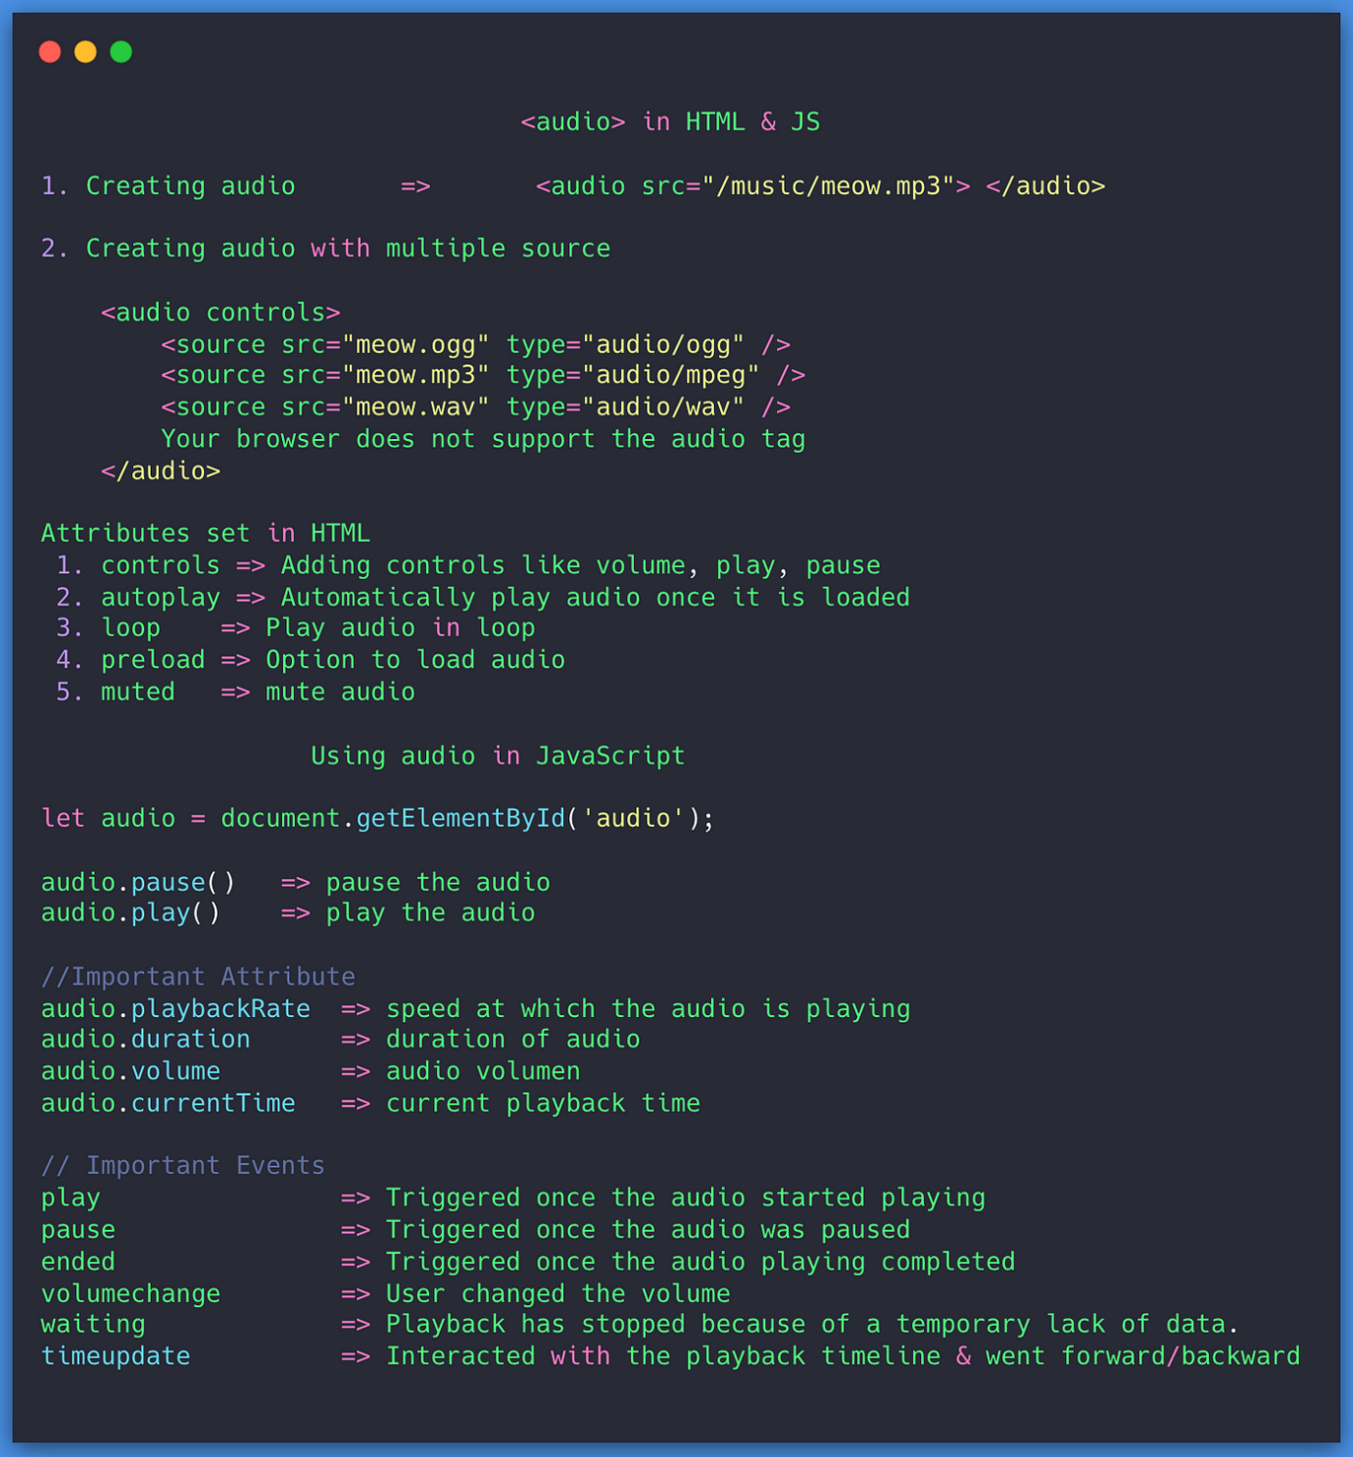
🔹 Images
<img src="car.jpg" alt="Red Car" width="300">
Attribute | Purpose
src | Image path
alt | SEO + Accessibility
width/height | Size
📌 ALT is mandatory (Interview 🔥)
Image Formats
• JPG – photos
• PNG – transparency
• SVG – icons
• WEBP – modern & optimized
🔹 Audio
<audio controls>
<source src="song.mp3">
</audio>
🔹 Video
<video controls muted width="300">
<source src="movie.mp4">
</video>
✔ controls | autoplay | loop | muted
📌 Autoplay works only when muted.

📊 9️⃣ HTML TABLES
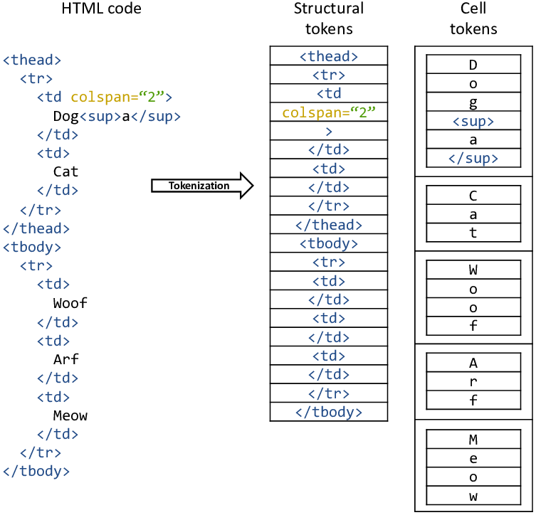
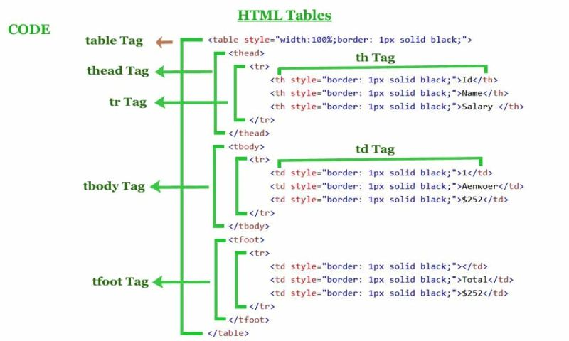
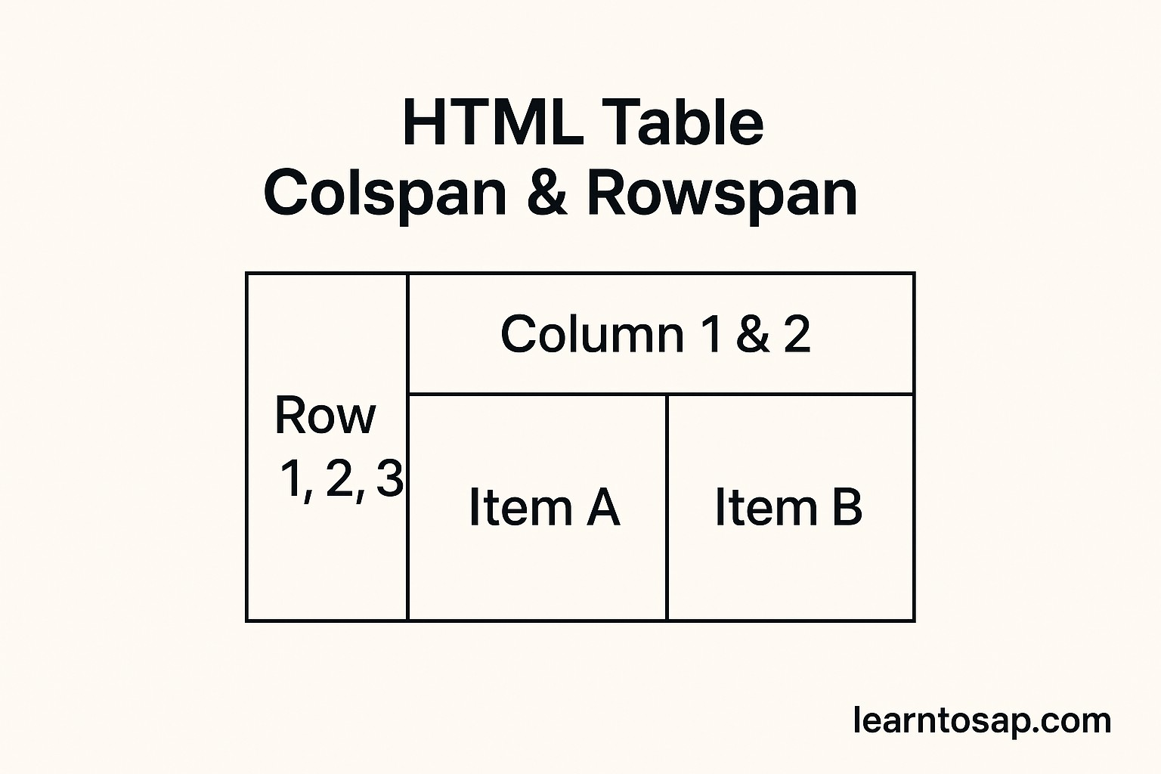

Tables are for tabular data only ❗ (Not layout)
🔹 Basic Table
<table>
<thead>
<tr><th>Name</th><th>Age</th></tr>
</thead>
<tbody>
<tr><td>John</td><td>25</td></tr>
</tbody>
</table>
🔹 Table Sections
• <thead> – header
• <tbody> – body
• <tfoot> – footer
🔹 Cell Merging
<td rowspan="2">Merge</td>
<td colspan="2">Merge</td>
📌 Improves readability & accessibility.

📋 🔟 HTML LISTS

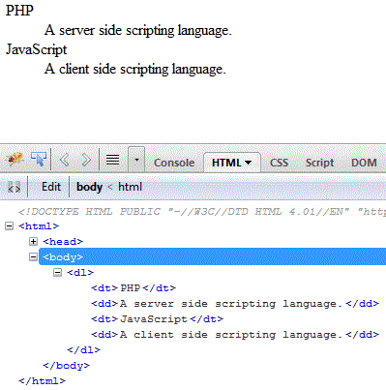
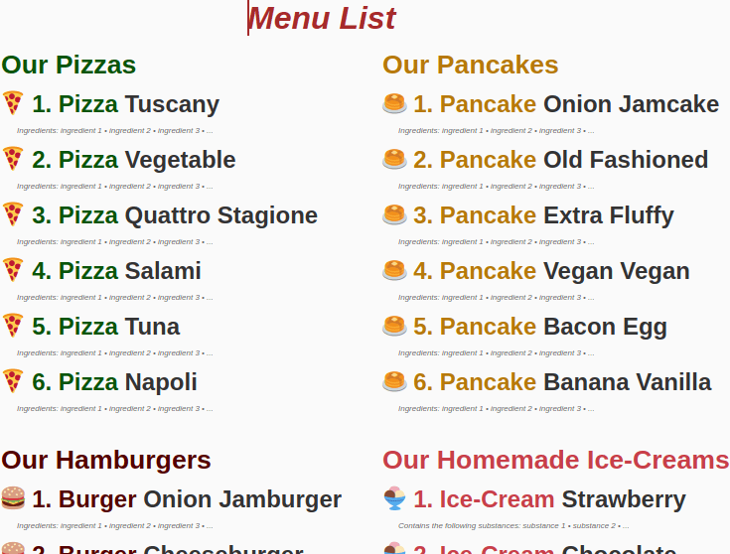
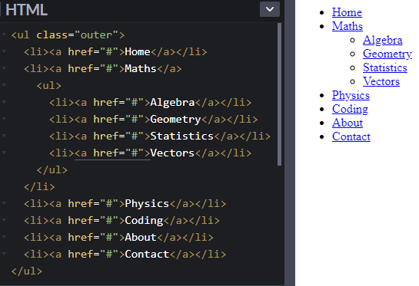
Lists group related content.
🔹 Ordered List <ol> (Steps)
<ol>
<li>Login</li>
<li>Select Course</li>
</ol>
🔹 Unordered List <ul> (Menus/Features)
<ul>
<li>HTML</li>
<li>CSS</li>
</ul>
🔹 Description List <dl> (Definitions)
<dl>
<dt>HTML</dt>
<dd>Structure language</dd>
</dl>
✔ Semantic + SEO friendly
Just tell me 🚀

